Table of Contents

1. Introduction 5

1.1 Purpose 5

1.2 Scope 5

1.3 Design and Implementation Constraints 5

1.4 Assumptions and Dependencies 5

1.5 Hardware Interfaces 5

1.6 Software Interfaces 6

1.7 Communications Interfaces 6

2. System Analysis 7

2.1 Identification of Stakeholder 7

2.2 Functional Requirement 8

2.2.1 Manage Artist: 8

2.2.2 Manage Customer: 8

2.2.3 Manage Shop: 8

2.2.4 Order Booking: 8

2.2.5 Payment: 8

2.2.6 Searching: 8

Admin, customer and artist can search any Artwork and Artist. 8

2.3 Non- Functional Requirement 9

2.3.1 Performance Requirements 9

2.3.2 Safety Requirements 9

2.3.3 Security Requirements 9

2.3.4 Lightweight 9

2.4 Initial Requirement Document 10

2.5 Use Case Diagram 11

2.6 Use Case Description 14

2.6.1 Artist Registration 14

2.6.2 Customer Registration 14

2.6.3 Upload Arts 15

2.6.4 Order Booking 15

2.7 Activity Diagram 16

2.8 Data Dictionary 23

2.8.1 Table: Artist 23

2.8.2 Table: Customer 29

2.8.3 Table: Contry 31

2.8.4 Table: State 31

2.8.5 Table: City 32

2.8.6 Table: Category 33

2.8.7 Table: Subject 34

2.8.8 Table:Shop 35

2.8.9 Table:Cart 41

2.8.10 Table:Shop_order 42

2.8.11 Table:ArtGallery 45

2.8.12 Table:ArtRating 46

2.8.13 Table:Artistrating 47

3. User Interface Design 48

4. Testing 57

4.1 Verification 57

4.2 Validation 61

5. Future Enhancement 64

5.2 Learning during the Project: - 64

References/Bibliography 65

List of Tables

Table 1:Initial Requirement Document 10

Table 2: usecase description of artist registration 14

Table 3: usecase description of customer registration 14

Table 4: usecase description of upload arts 15

Table 5: usecase description of order booking 15

Table 6: tbl_artist 23

Table 7 : tbl_customer 29

Table 8 : tbl_country 31

Table 9 : tbl_state 31

Table 10 : tbl_city 32

Table 11 : tbl_category 33

Table 12 : tbl_subject 34

Table 13 : tbl_shop 35

Table 14 : tbl_cart 41

Table 15 : tbl_shoporder 42

Table 16 : tbl_ArtGallery 45

Table 17 : tbl_ArtRating 46

Table 18 : tbl_artistrating 47

Table 19 : Test Case: Login 57

Table 20 : Test Case: Artist Registration 58

Table 21 : Test Case: Customer Registration 60

List of Figures

Figure 1: Use Case Admin 11

Figure 2: Use Case Artist 12

Figure 3: Use Case Customer 13

Figure 4: Login Activity 16

Figure 5: Registration Activity 17

Figure 6: manage artist activity 18

Figure 7: manage customer activity 19

Figure 8: manage shop activity 20

Figure 9: manage gallery acivity 21

Figure 10: order booking activity 22

Figure 11 : Home Page 46

Figure 12 : Gallery Page 46

Figure 13 : Artist Page 47

Figure 14 : Artist Profile-Page 47

Figure 15 : Shop Page 48

Figure 16: Art Details Page 48

Figure 17 : Login Page 49

Figure 18 : Artist Home Page 49

Figure 19 : Upload Arts 50

Figure 20 : Artist Update Profile-Images 50

Figure 21 : Artist Update Profile-Account-Info 51

Figure 22 : Artist Update Profile-Profile-Info 51

Figure 23 : Customer Home 52

Figure 24 : Customer View-Artist-Profile 52

Figure 25 : Customer Profile 53

Figure 26 : Cart Page 53

Figure 27 : Checkout Page 54

Figure 28 : Login Validation 1 59

Figure 29 : Login Validation 2 59

Figure 30 : Login Validation 3 60

Figure 31 : Artist Registration Validation 60

Figure 32 : Customer Registration Validation 61

# Introduction

## Purpose

Online Art Gallery is an efficient web application which gives various opportunities to the artists for publishing their artwork. System allows artists to upload their artwork in shop and customers can purchase from the shop.

## Scope

Online art gallery system is only for the art personals as well as for those customers who are passionate about arts. Currently this system is limited for India. This system does not follow the traditional art categories, instead we bifurcate different types of arts based on modern era. The system is feasible for visual arts.

## Design and Implementation Constraints

* Designing implementation is done by using HTML, CSS, JavaScript, jQuery.
* Backend implementation is done by using PHP.

## Assumptions and Dependencies

* Payment is dependent on PayUMoney.
* User communicate through email and SMS.

## Hardware Interfaces

* Processor: Intel core i3 or higher
* Hard disk: 5 GB Hard Disk Space or higher
* RAM: 8GB RAM or Higher

## Software Interfaces

* **Frontend**
* Bootstrap
* Html
* CSS
* **Backend**
* Php
* Apache Server
* **Tools**
* NetBeans
* Umlet
* **Database**
* MySql

## Communications Interfaces

* Email:

Email send to both customer as well as artist for notification of forget password.

* SMS:

SMS send to Admin for notification of payment.

# System Analysis

## Identification of Stakeholder

1. **Admin:**

* Admin has static login in the system.
* Admin can manage Artists and Customers.
* Admin can manage Gallery.
* Admin can view the Shop details.
* Admin can view the ratings of Artworks and Artists profile.
* Admin can manage the order tracing.

1. **Artist:**

* Artist need to register in the system before login.
* Artist can manage his/her own profile.
* Artist has access to the gallery but cannot update or manipulate any details in gallery.
* Artist can manage shop details by adding his/her personal product in the shop for sale.
* Artist can view ratings done on his/her art work or on his/her profile by the customers.

1. **Customer:**

* Customer need to register in the system before login.
* Customer can manage his/her own profile and can view other artist profiles.
* Customer has access to the gallery but cannot update or manipulate any details in gallery.
* Customer has rights for purchasing arts of artists from the shop and can order for the same.
* Customer can rate the art work and artist profile and can view the ratings done by other customers.

## Functional Requirement

### Manage Artist:

Admin can add, remove, update and view artist details.

Artist can also handle their own profile.

### Manage Customer:

Admin can add, remove, update and view customer.

Artist can also manage their customers.

Customer can also handle their own profile.

### Manage Shop:

Artist can upload their arts in the shop for selling and also manage the shop details.

### Order Booking:

Customer can order the arts from the shop.

### Payment:

Online payment through PayUMoney.

### Searching:

### Admin, customer and artist can search any Artwork and Artist.

## Non- Functional Requirement

### Performance Requirements

* The System need to be reliable.
* If processes are inappropriate then error message will display.

### Safety Requirements

* Session is maintained so if any user logout the system cannot access the system without login.

### Security Requirements

* For make system more secure MD5 algorithm will encrypt the password.
* QR scan for the security of the artist.

### Lightweight

* We have used a modern JavaScript framework jQuery provides the service of transferring data without page refresh from client to server and vice versa.
* It makes the system lightweight.

## Initial Requirement Document

Table :Initial Requirement Document

|  |  |
| --- | --- |
| Title of the project: | Online Art Gallery |
| Stakeholders involved in capturing requirements: | Guide  Client |
| Techniques used for requirement capturing: | Interview |
| Name of the persons along with the designation: | Mr. Sapan Naik as a guide. (As a Professor) |
| Date: | 20th December 2017 |
| Version: | 1.0 |
| Consolidated list of initial requirements:   1. A system is to be implemented registration of artist and customer. 2. A system is to be implemented Login with username. 3. A system must be used if login id and password are valid. 4. A system must manage customer & artist. 5. Artist must be able to upload arts. 6. Customer must be able to purchase arts. 7. A system must implement about us and contact us functionalities. 8. A system must provide searching facility. | |

## Use Case Diagram

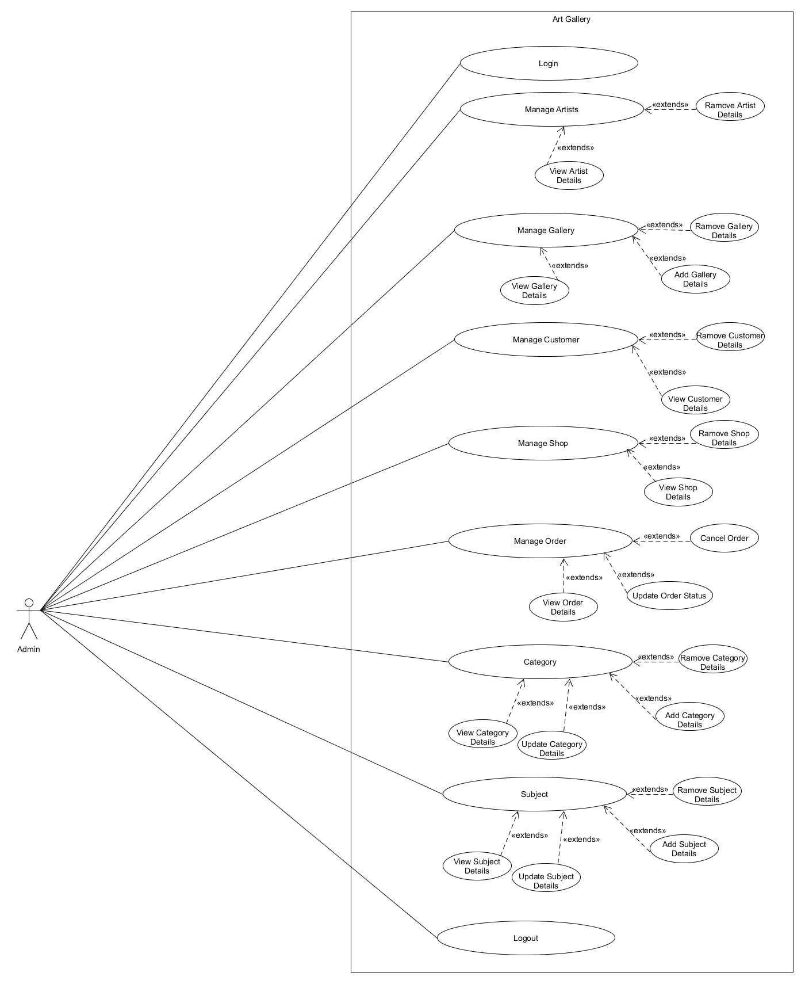

Figure 1: Use Case Admin

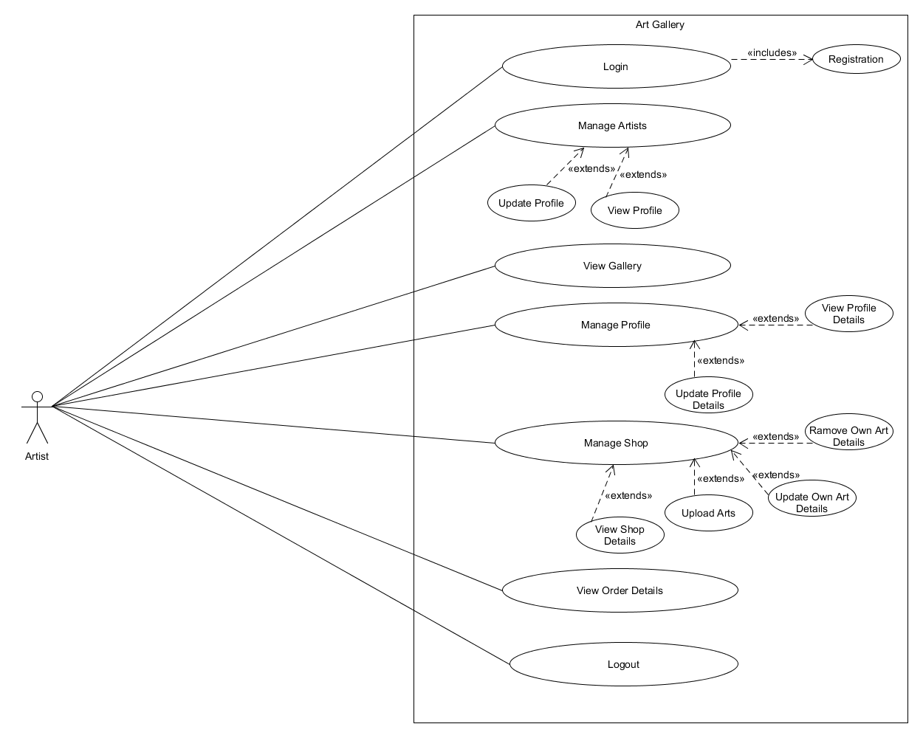

Figure 2: Use Case Artist

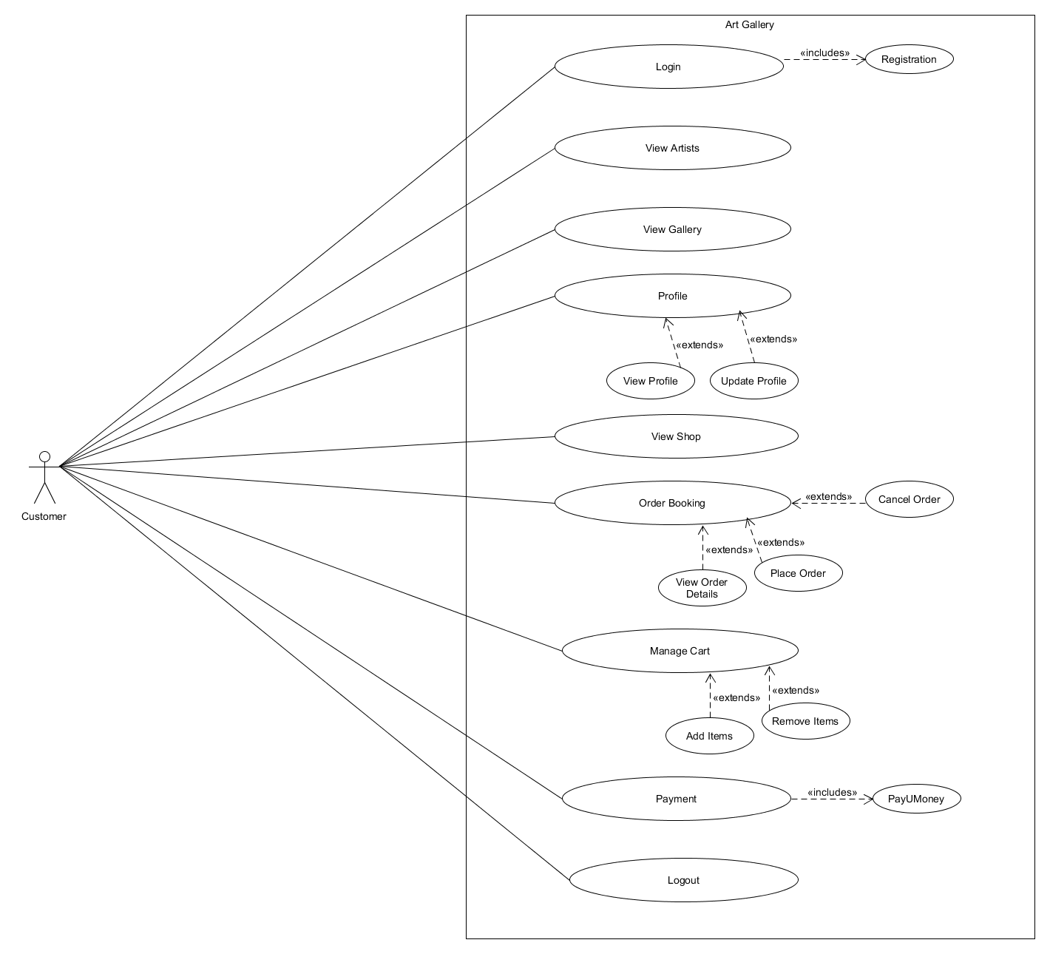

Figure 3: Use Case Customer

## Use Case Description

### Artist Registration

Table : usecase description of artist registration

|  |
| --- |
| **Introduction:** This use case documents the steps that must be followed in order to registering artist. |
| **Actors:**  Artist |
| **Precondition:** The details of artist is successfully registered. |
| **Post-condition:** The artist can login the system. |
| **Event Flow:**   1. The artist enters personal details of own. 2. Artist submits the form. |
| **Alternative Flow:**   1. Internet connection lost. 2. Artist exits. 3. Any other technical problem. |
| **Special Requirement:**  None |
| **Associated Use Case:**  Artist Login |

### 

### Customer Registration

Table : usecase description of customer registration

|  |
| --- |
| **Introduction:** This use case documents the steps that must be followed in order to registering customer. |
| **Actors:**  Customer |
| **Precondition:** The details of customer is successfully registered. |
| **Post-condition:** The customer can login the system. |
| **Event Flow:**   1. The customer enters personal details of own. 2. Customer submits the form. |
| **Alternative Flow:**   1. Internet connection lost. 2. Customer exits. 3. Any other technical problem. |
| **Special Requirement:**  None |
| **Associated Use Case:**  Customer Login |

### Upload Arts

Table : usecase description of upload arts

|  |
| --- |
| **Introduction:** This use case documents the steps that must be followed in order to upload arts. |
| **Actors:**  Artist |
| **Precondition:** The artist must be logged in the system. |
| **Post-condition:** Artist can sell the arts in shop. |
| **Event Flow:**   1. The artist enters art details. 2. Artist submits the form. |
| **Alternative Flow:**   1. Internet connection lost. 2. Artist exits. 3. Any other technical problem. |
| **Special Requirement:**  None |
| **Associated Use Case:**  Artist upload arts |

### Order Booking

Table : usecase description of order booking

|  |
| --- |
| **Introduction:** This use case documents the steps that must be followed in order to book order. |
| **Actors:**  Customer |
| **Precondition:** The customer must be logged in the system. |
| **Post-condition:** Customer can purchase the arts in shop. |
| **Event Flow:**   1. The customer enters booking and payment details. 2. Customer submits the form. |
| **Alternative Flow:**   1. Internet connection lost. 2. Customer exits. 3. Any other technical problem. |
| **Special Requirement:**  None |
| **Associated Use Case:**  Customer order booking |

## Activity Diagram

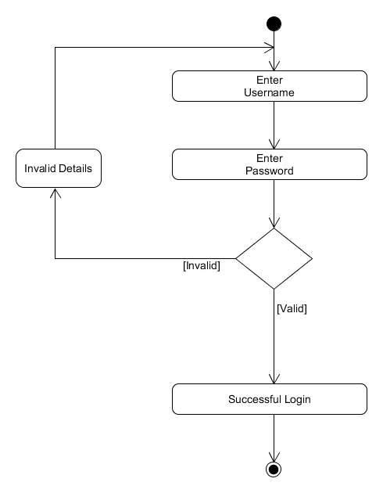

Figure 4: Login Activity

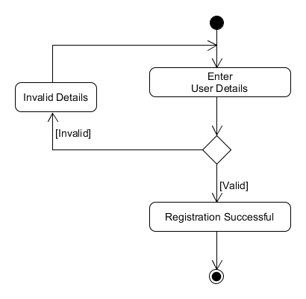

Figure 5: Registration Activity

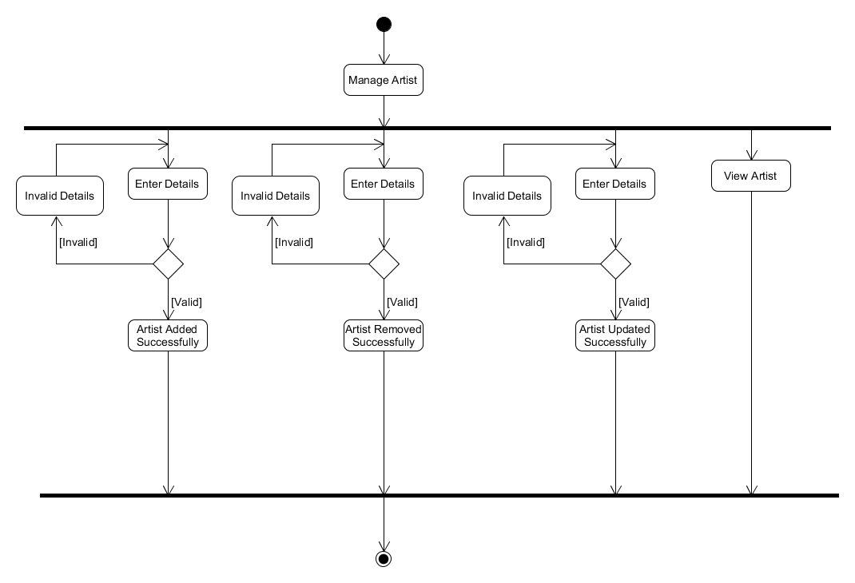

Figure 6: manage artist activity

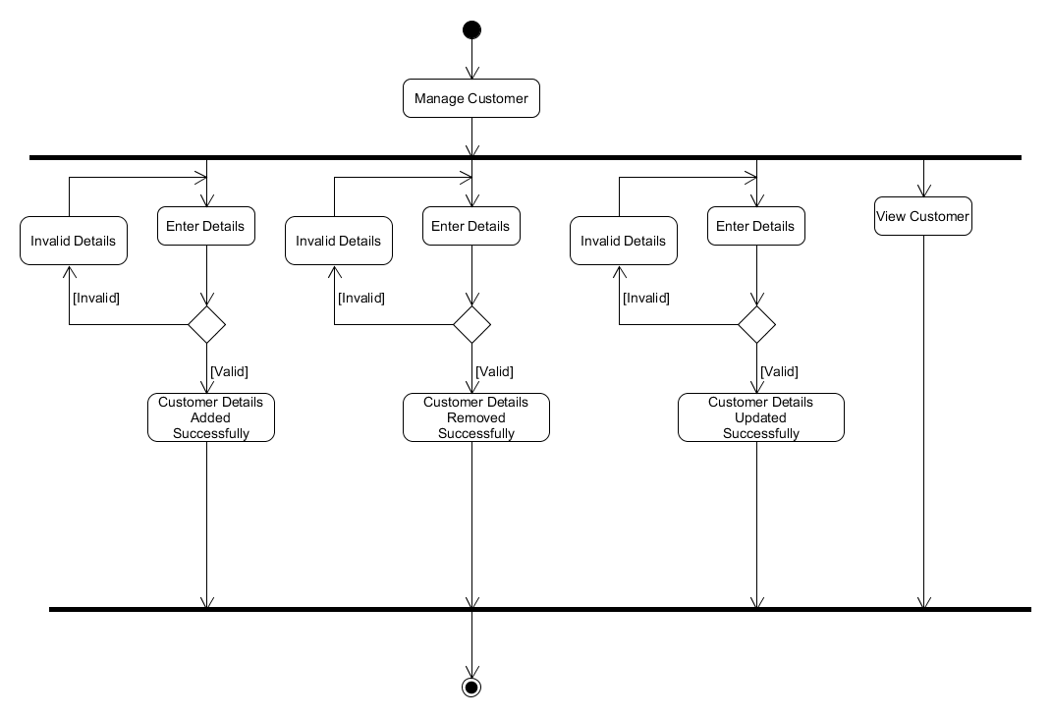

Figure 7: manage customer activity

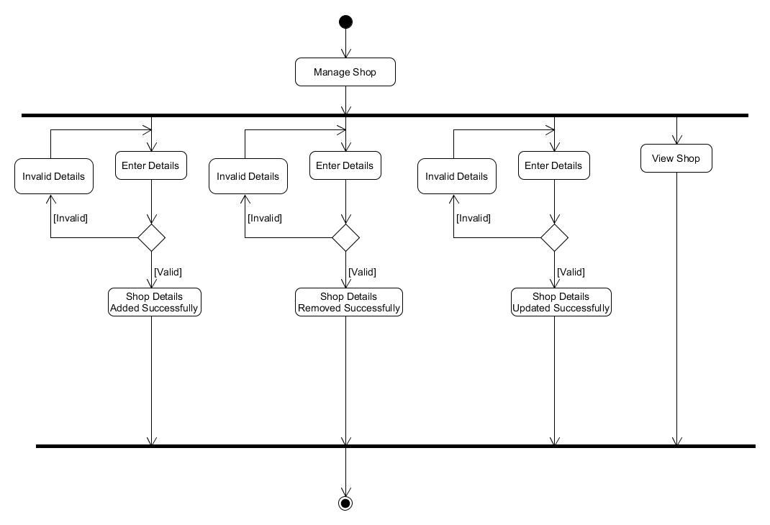

Figure 8: manage shop activity

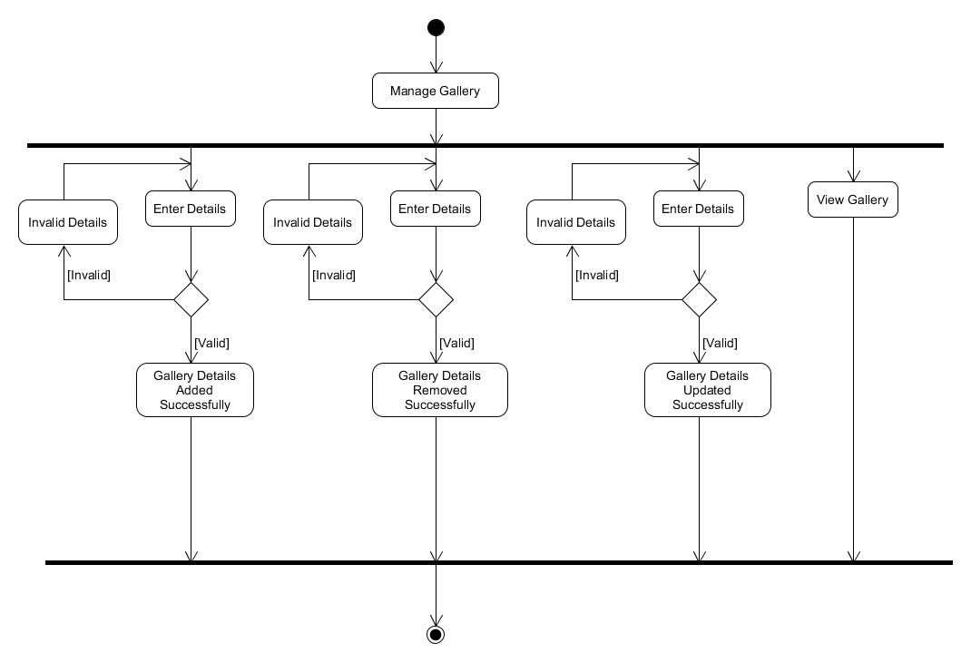

Figure 9: manage gallery acivity

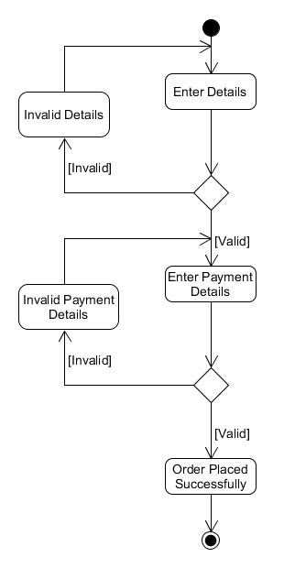

Figure 10: order booking activity

## Data Dictionary

## 2.8.1 Table: Artist

Table : tbl_artist

|  |  |  |  |  |
| --- | --- | --- | --- | --- |
| **Field Name** | **Datatype** | **Size** | **Constrain** | **Description** |
| Artist_Id | Integer | - | Primary Key | Unique Id |
| firstname | Varchar | 15 | Not null | First name of the artist |
| lastname | Varchar | 15 | Not null | Last name of the artist |
| username | Varchar | 30 | Not null | Username of the artist for login |
| password | Varchar | Max | Not null | Password of the artist for login |

**Cont…..**

|  |  |  |  |  |
| --- | --- | --- | --- | --- |
| **Field Name** | **Datatype** | **Size** | **Constrain** | **Description** |
| email_Id | Varchar | 30 | Not null | Email id of the artist |
| contact_number | Varchar | 13 | Not null | Artist contact number |
| date_of_birth | Date | - | Not null | Artist birth date |
| city_id | Integer | - | Foreign Key | City id as reference |
| qrimg | Varchar | Max | Not null | Path of an Qr image |

**Cont…..**

|  |  |  |  |  |
| --- | --- | --- | --- | --- |
| **Field Name** | **Datatype** | **Size** | **Constrain** | **Description** |
| qrcode | Varchar | 30 | Not null | Value of qrcode |
| profile_image | Varchar | Max | Not null | Path of profile image |
| idproof_image | Varchar | Max | Not null | Path of Id proof image |
| legal_name | Varchar | 30 | Not null | Legal name of an artist as per government id proof |

**Cont…..**

|  |  |  |  |  |
| --- | --- | --- | --- | --- |
| **Field Name** | **Datatype** | **Size** | **Constrain** | **Description** |
| street_address | Varchar | Max | Null | Street address of an artist |
| state_id | Integer | - | Foreign key | State id as reference |
| country_id | Integer | - | Foreign key | Country id as reference |
| zipcode | Integer | - | Not null | Zipcode of artist residence |
| about_me | Varchar | Max | Null | Description about the artist |

**Cont…..**

|  |  |  |  |  |
| --- | --- | --- | --- | --- |
| **Field Name** | **Datatype** | **Size** | **Constrain** | **Description** |
| education | Varchar | Max | Null | Education details of an artist |
| artist_googleplus | Varchar | Max | Null | Link of google+ account of an artist |
| artist_twitter | Varchar | Max | Null | Link of twitter account of an artist |
| artist_facebook | Varchar | Max | Null | Link of facebook account of an artist |

**Cont…..**

|  |  |  |  |  |
| --- | --- | --- | --- | --- |
| **Field Name** | **Datatype** | **Size** | **Constrain** | **Description** |
| artist_instagram | Varchar | Max | Null | Link of instagram account of an artist |
| artist_website | Varchar | Max | Null | Personal website link of an artist |
| status | Varchar | 8 | Not null | Active / Deactive status of an artist account |
| verification | Varchar | 8 | Not null | Pending / Approved verification of an artist account |

## 2.8.2 Table: Customer

Table : tbl_customer

|  |  |  |  |  |
| --- | --- | --- | --- | --- |
| **Field Name** | **Datatype** | **Size** | **Constrain** | **Description** |
| Customer_Id | Integer | - | Primary key | Unique Id |
| Firstname | Varchar | 15 | Not null | Firstname of customer |
| Lastname | Varchar | 15 | Not null | Lastname of customer |
| Username | Varchar | 30 | Not null | Username of the customer for login |

**Cont…..**

|  |  |  |  |  |
| --- | --- | --- | --- | --- |
| **Field Name** | **Datatype** | **Size** | **Constrain** | **Description** |
| Email_Id | Varchar | 30 | Not null | Email id of customer |
| Contact_Number | Varchar | 13 | Not null | Contact number of customer |
| Profile_Image | Varchar | Max | Not null | Path of profile image of customer |
| status | Varchar | 8 | Not null | Active / Deactive status of a customer account |

## 2.8.3 Table: Contry

Table : tbl_country

|  |  |  |  |  |
| --- | --- | --- | --- | --- |
| **Field Name** | **Datatype** | **Size** | **Constrain** | **Description** |
| Country_Id | Integer | - | Primary key | Unique id |
| Country_Name | Varchar | 15 | Not null | Name of the Country |

## 

## 2.8.4 Table: State

Table : tbl_state

|  |  |  |  |  |
| --- | --- | --- | --- | --- |
| **Field Name** | **Datatype** | **Size** | **Constrain** | **Description** |
| State_Id | Integer | - | Primary key | Unique id |
| State_Name | Varchar | 15 | Not null | Name of the State |
| Country_Id | Integer | - | Foreign key | Country id as a reference |

## 2.8.5 Table: City

Table : tbl_city

|  |  |  |  |  |
| --- | --- | --- | --- | --- |
| **Field Name** | **Datatype** | **Size** | **Constrain** | **Description** |
| City_Id | Integer | - | Primary key | Unique id |
| City_Name | Varchar | 15 | Not null | Name of the city |
| State_Id | Integer | - | Foreign key | State id as a reference |

## 

## 2.8.6 Table: Category

Table : tbl_category

|  |  |  |  |  |
| --- | --- | --- | --- | --- |
| **Field Name** | **Datatype** | **Size** | **Constrain** | **Description** |
| Category_Id | Integer | - | Primary key | Unique id for different category recognition |
| Category_Name | Varchar | 15 | Not null | Category of art which will be having subjects |
| Status | Varchar | 8 | Not null | Activate or Deactivate  Category |

## 2.8.7 Table: Subject

Table : tbl_subject

|  |  |  |  |  |
| --- | --- | --- | --- | --- |
| **Field Name** | **Datatype** | **Size** | **Constrain** | **Description** |
| Subject_Id | Integer | - | Primary key | Unique id for subject recognition |
| Subject_Name | Varchar | 15 | Not null | Subject of art based on various categories |
| Status | Varchar | 8 | Not null | Activate or Deactivate  Subject |

## Table:Shop

Table : tbl_shop

|  |  |  |  |  |  |
| --- | --- | --- | --- | --- | --- |
| **Field Name** | **Datatype** | **Size** | **Constrain** | **Description** | **Field Name** |
| Shop_Id | Integer | - | Primary key | Unique id | Shop_Id |
| Artist_Id | Integer | - | Foriegn key | Artist id as a reference | Artist_Id |
| Art_Title | Varchar | 20 | Not null | Title Of an Artwork | Art_Title |
| Art_File | Varchar | Max | Not null | Path of Image file of an Artwork | Art_File |
| Art_Category | Varchar | 12 | Not null | Category of an Artwork | Art_Category |

**Cont…..**

|  |  |  |  |  |
| --- | --- | --- | --- | --- |
| **Field Name** | **Datatype** | **Size** | **Constrain** | **Description** |
| Art_Subject | Varchar | 12 | Not null | Subject of an Artwork |
| Year | Integer | - | Not null | Year of creation of an Artwork |
| Art_Mediums | Varchar | Max | Not null | Mediums of an Artwork |
| Art_Materials | Varchar | Max | Not null | Materials of an Artwork |
| Art_Styles | Varchar | Max | Not null | Styles of an Artwork |

**Cont…..**

|  |  |  |  |  |
| --- | --- | --- | --- | --- |
| **Field Name** | **Datatype** | **Size** | **Constrain** | **Description** |
| Art_Keyword | Varchar | Max | Not null | Keywords of an Artwork |
| Height | Float | - | Not null | Height of an Artwork |
| Width | Float | - | Not null | Width of an Artwork |
| Description | Varchar | Max | Not null | Description of an Artwork |
| Zipcode | Integer | - | Not null | Zipcode from where Artwork will be dispatched |

**Cont…..**

|  |  |  |  |  |
| --- | --- | --- | --- | --- |
| **Field Name** | **Datatype** | **Size** | **Constrain** | **Description** |
| Price | Double | - | Not null | Price of an Artwork |
| Shipping_Cost | Double | - | Not null | Shipping cost of an Artwork |
| Total_Amount | Double | - | Not null | Total amount of an Artwork |
| Date | Varchar | 10 | Not null | Uploading date of an Artwork |

**Cont…..**

|  |  |  |  |  |
| --- | --- | --- | --- | --- |
| **Field Name** | **Datatype** | **Size** | **Constrain** | **Description** |
| Street_Address | Varchar | Max | Not null | Street address from where Artwork will be dispatched |
| City_Id | Integer | - | Not null | City id as a reference |
| State_Id | Integer | - | Not null | State id as a reference |
| Country_Id | Integer | - | Not null | Country id as a reference |

**Cont…..**

|  |  |  |  |  |
| --- | --- | --- | --- | --- |
| **Field Name** | **Datatype** | **Size** | **Constrain** | **Description** |
| Price | Double | - | Not null | Price of an Artwork |
| Ship_Cost | Double | - | Not null | Shipping cost of an Artwork |
| Date | Varchar | 10 | Not null | Uploading Date of an Artwork |
| Time | Varchar | 8 | Not null | Uploading Time of an Artwork |

## 2.8.9 Table:Cart

Table : tbl_cart

|  |  |  |  |  |
| --- | --- | --- | --- | --- |
| **Field Name** | **Datatype** | **Size** | **Constrain** | **Description** |
| Cart_Id | Integer | - | Primary key | Unique id |
| Shop_Id | Integer | - | Foreign key | Shop id as a reference |
| Customer_Id | Integer | - | Foreign key | Customer id as a reference |
| Quantity | Interger | - | Not null | Purchase quantity  Of an Artwork |
| Total_Price | Double | - | Not null | Total price of an Artwork |
| Cart_Status | Integer | - | Not null | Cart Status for available or not in cart |

## 2.8.10 Table:Shop_order

Table : tbl_shoporder

|  |  |  |  |  |
| --- | --- | --- | --- | --- |
| **Field Name** | **Datatype** | **Size** | **Constrain** | **Description** |
| ShopOrder_Id | Integer | - | Primary key | Unique id |
| Cart_Id | Integer | - | Foreign key | Cart id as a reference |
| Email_Id | Varchar | Max | Not null | Email id of an Customer |
| Contact_Number | Varchar | 13 | Not null | Contact number of Customer |
| Street_Address | Varchar | Max | Not null | Street address at where Artwork will be Deliver |

**Cont…..**

|  |  |  |  |  |
| --- | --- | --- | --- | --- |
| **Field Name** | **Datatype** | **Size** | **Constrain** | **Description** |
| City_Id | Integer | - | Not null | City Id as a reference |
| State_Id | Integer | - | Not null | State Id as a reference |
| Country_Id | Integer | - | Not null | Country Id as a reference |
| Zipcode | Integer | - | Not null | Zipcode of entered by customer |
| Status | Varchar | 12 | Not null | Tracking status of an Artwork |

**Cont…..**

|  |  |  |  |  |
| --- | --- | --- | --- | --- |
| **Field Name** | **Datatype** | **Size** | **Constrain** | **Description** |
| Amount | Double | - | Not null | Total amount will be paid by customer |
| Date | Varchar | 10 | Not null | Purchasing Date of an Artwork |
| Time | Varchar | 8 | Not null | Purchasing Time of an Artwork |

## 2.8.11 Table:ArtGallery

Table : tbl_ArtGallery

|  |  |  |  |  |
| --- | --- | --- | --- | --- |
| **Field Name** | **Datatype** | **Size** | **Constrain** | **Description** |
| ArtGallery_Id | Integer | - | Primary key | Unique id |
| File | Varchar | Max | Not null | Path of the gallery image |
| Status | Varchar | 10 | Not null | Activate or Deactivate  Gallery |

## 2.8.12 Table:ArtRating

Table : tbl_ArtRating

|  |  |  |  |  |
| --- | --- | --- | --- | --- |
| **Field Name** | **Datatype** | **Size** | **Constrain** | **Description** |
| ArtRating_Id | Integer | - | Primary key | Unique id |
| Shop_Id | Integer | - | Foreign key | Shop id as a reference |
| Customer_ Username | Integer | - | Not null | Customer username as a reference |
| Ratings | Integer | - | Not null | Ratings by the customer |

## 2.8.13 Table:Artistrating

Table : tbl_artistrating

|  |  |  |  |  |
| --- | --- | --- | --- | --- |
| **Field Name** | **Datatype** | **Size** | **Constrain** | **Description** |
| ArtistRating_Id | Integer | - | Primary key | Unique id |
| Artist_Id | Integer | - | Foreign key | Artist id as a reference |
| Customer_  Username | Integer | - | Not null | Customer username as a reference |
| Ratings | Integer | - | Not null | Ratings by the customer |

# User Interface Design

1. **Home**

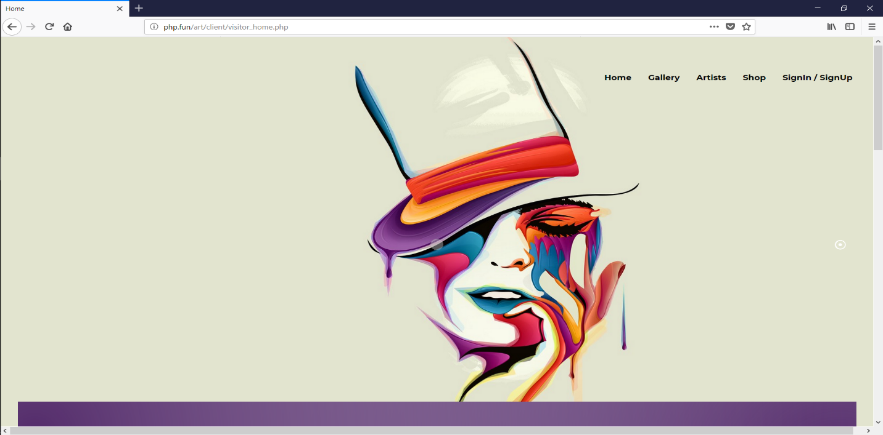

Figure : Home Page

The above picture shows user interface of home screen.

1. **Gallery**

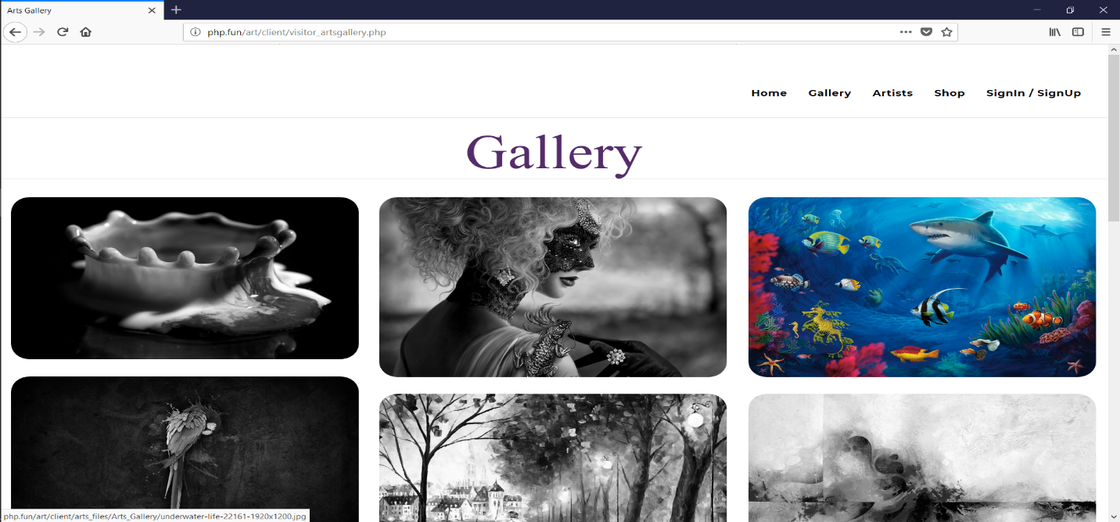

Figure : Gallery Page

The above picture shows user interface of home screen.

1. **Artist**

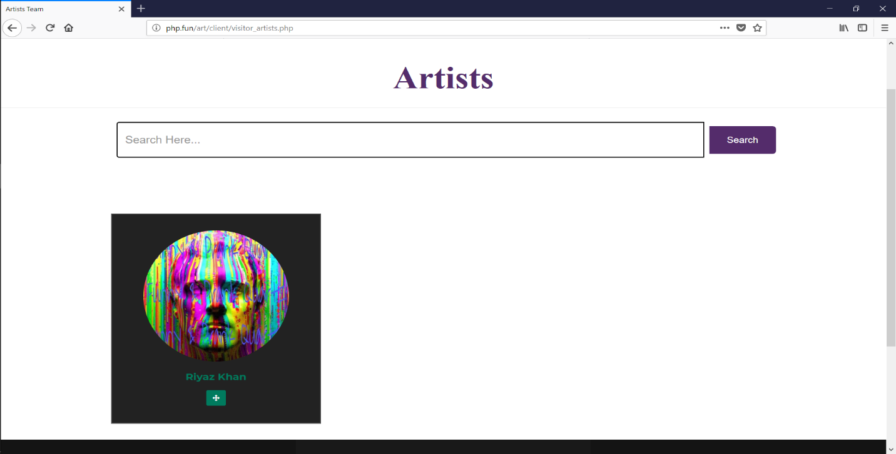

Figure : Artist Page

The above picture shows user interface of artist screen.

1. Artist Profile Page

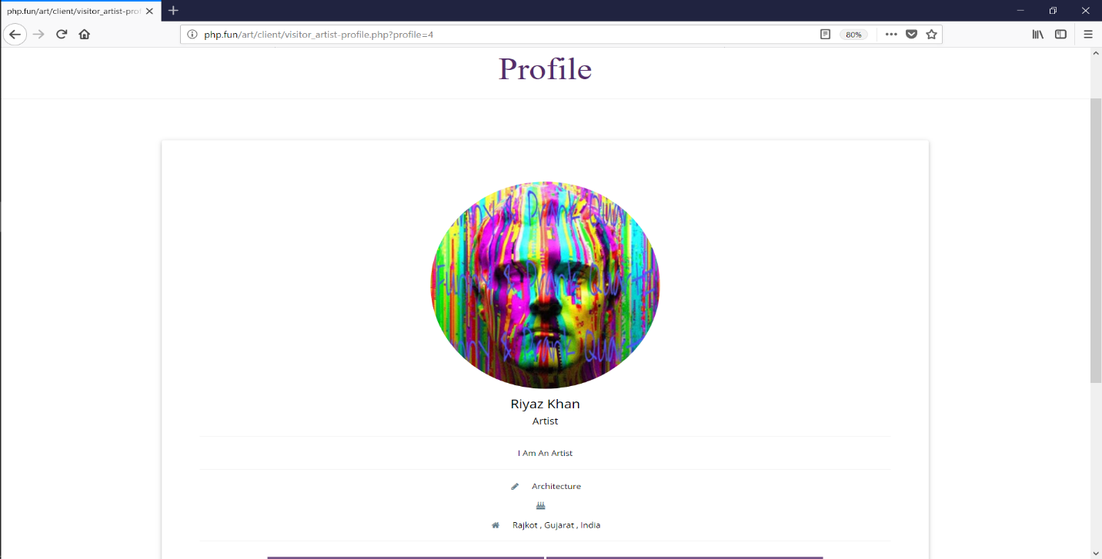

Figure : Artist Profile-Page

The above picture shows user interface of artist profile screen.

1. Shop Page

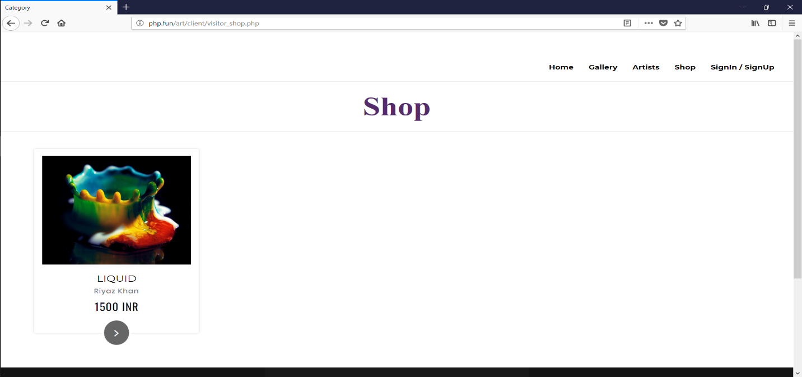

Figure : Shop Page

The above picture shows user interface of shop screen.

1. Art Details Page

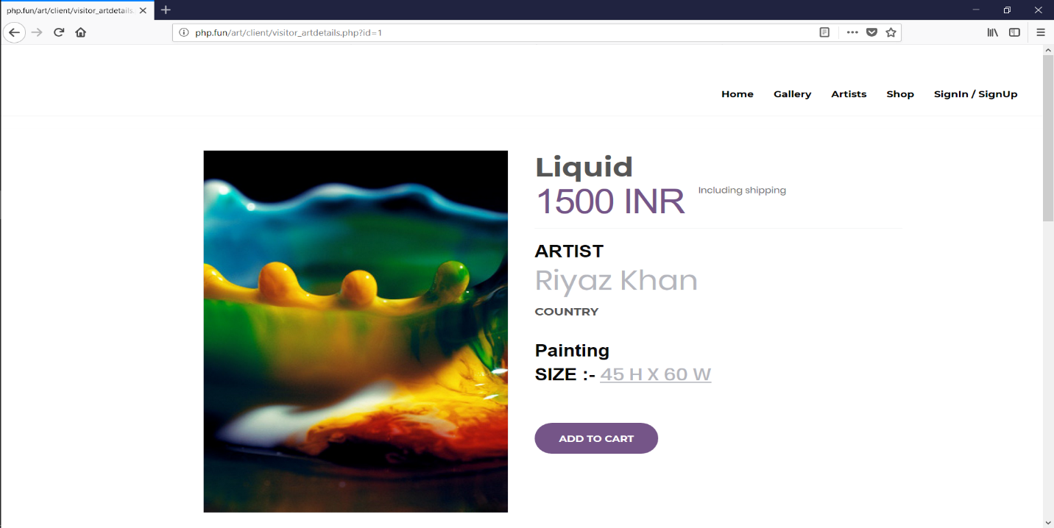

Figure : Art Details Page

The above picture shows user interface of art details screen.

1. Log In Page

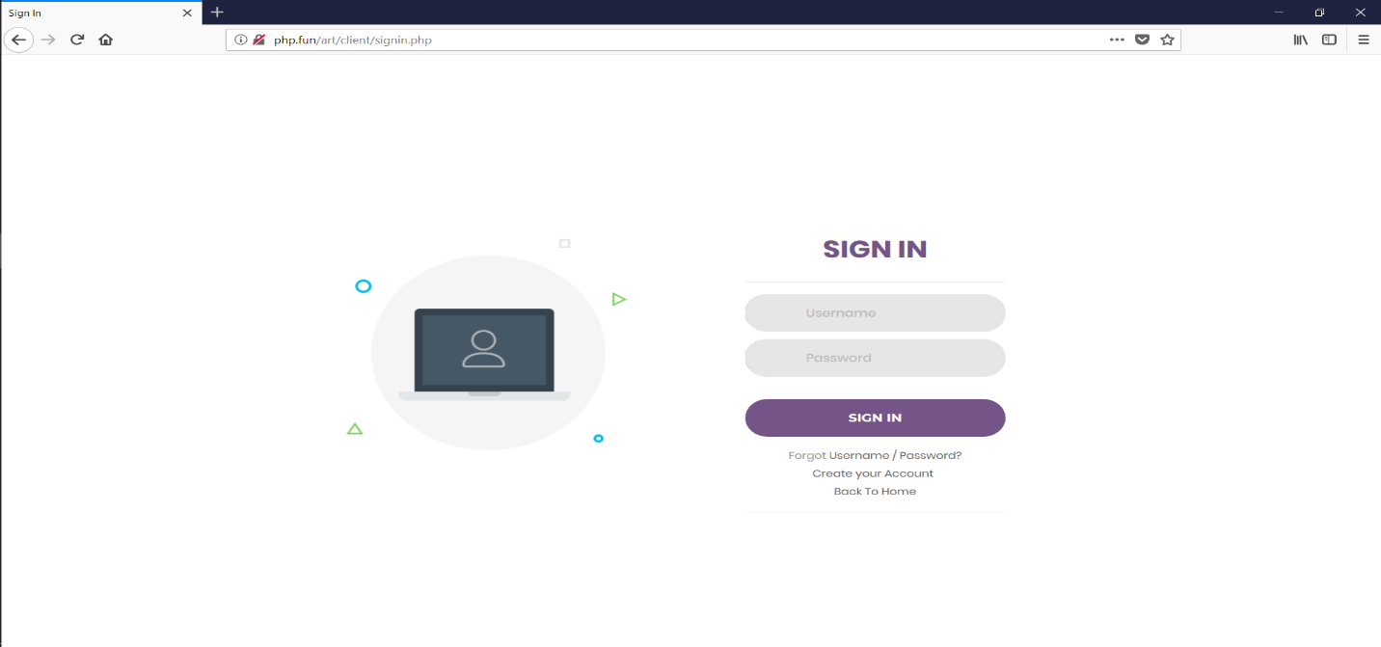

Figure : Login Page

The above picture shows user interface of login screen.

1. Artist Home Page

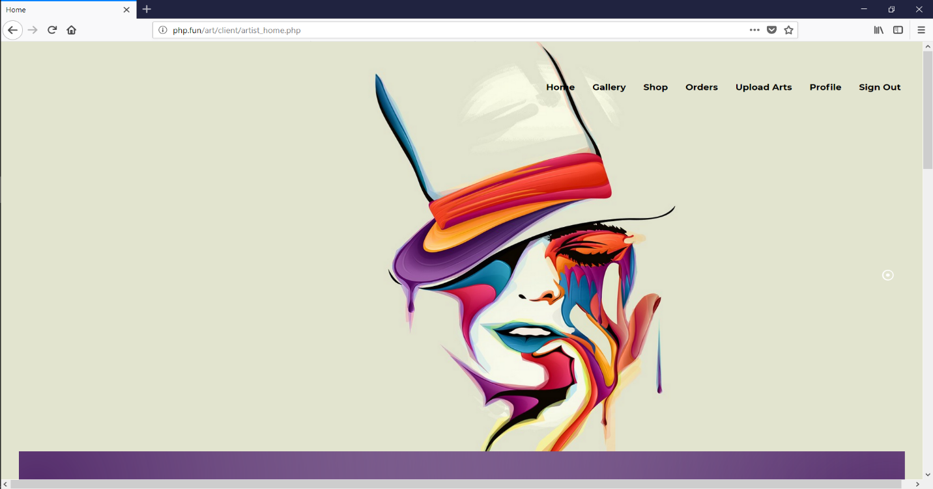

Figure : Artist Home Page

The above picture shows user interface of artist home screen.

1. Upload Arts

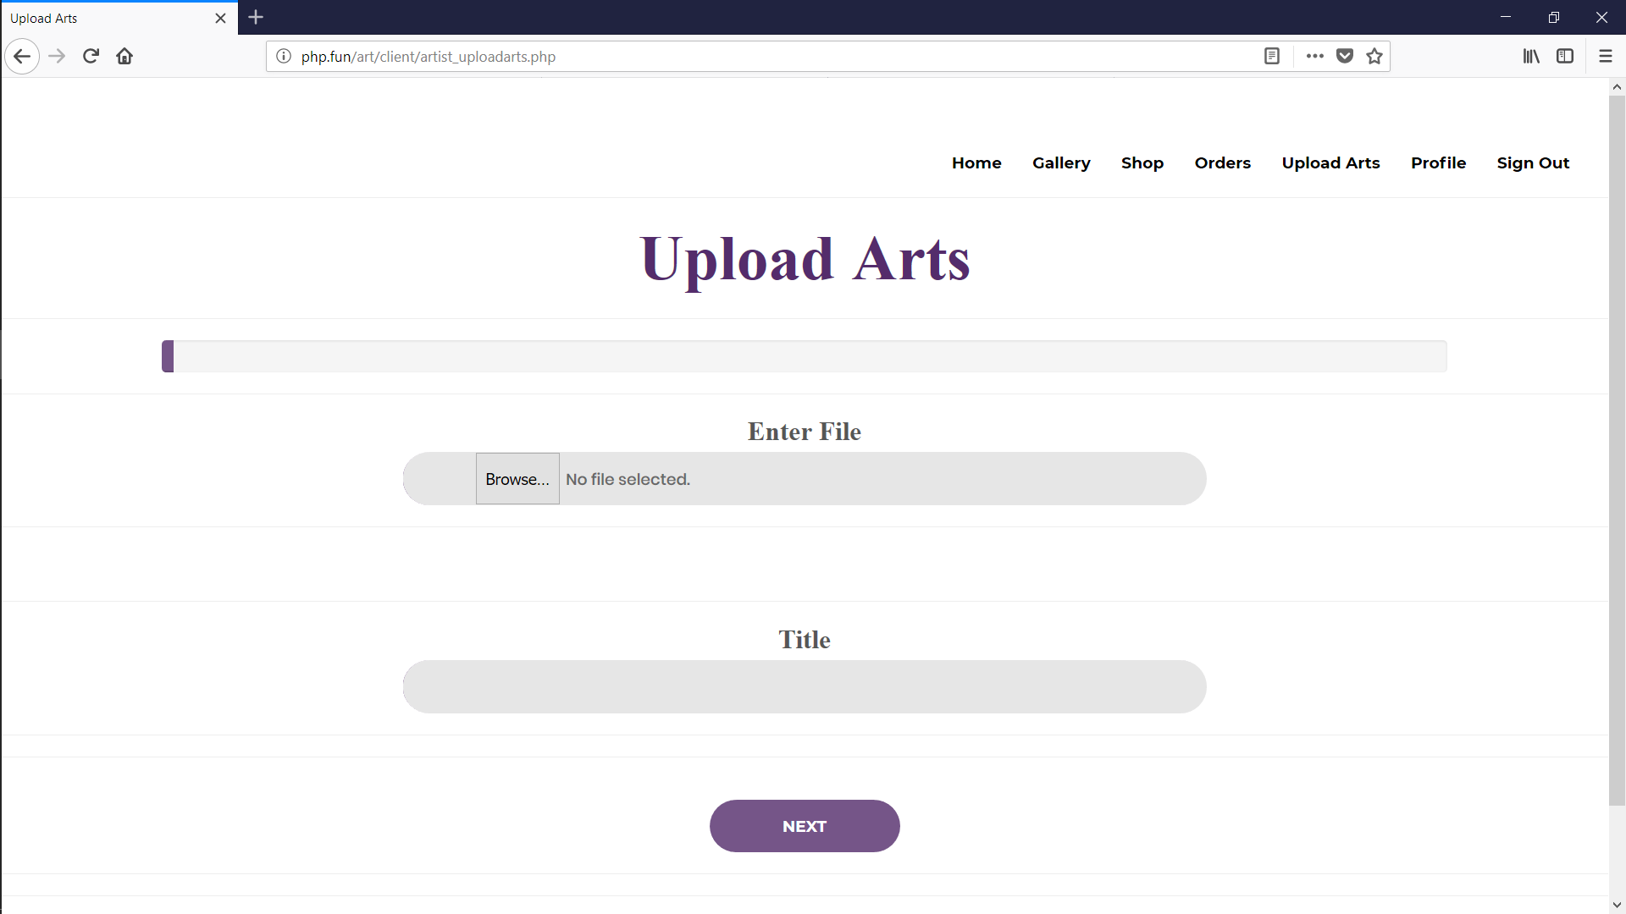

Figure : Upload Arts

The above picture shows user interface of upload arts details screen.

1. Artist Update Profile-images

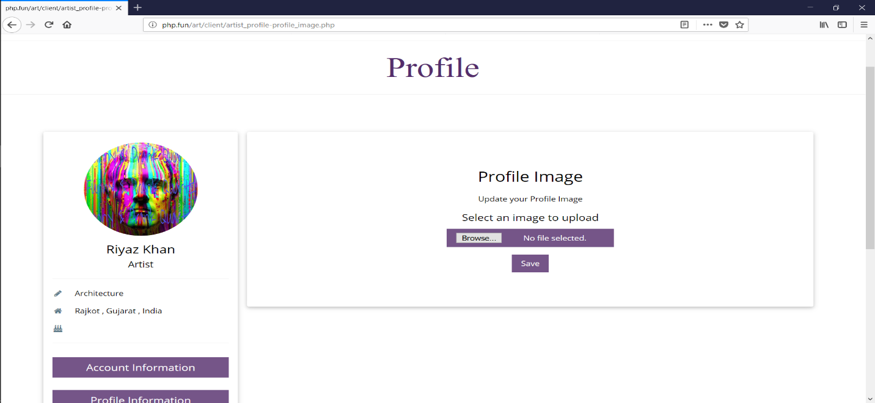

Figure : Artist Update Profile-Images

The above picture shows user interface of art details screen.

1. Artist Update Profile-Account-Info

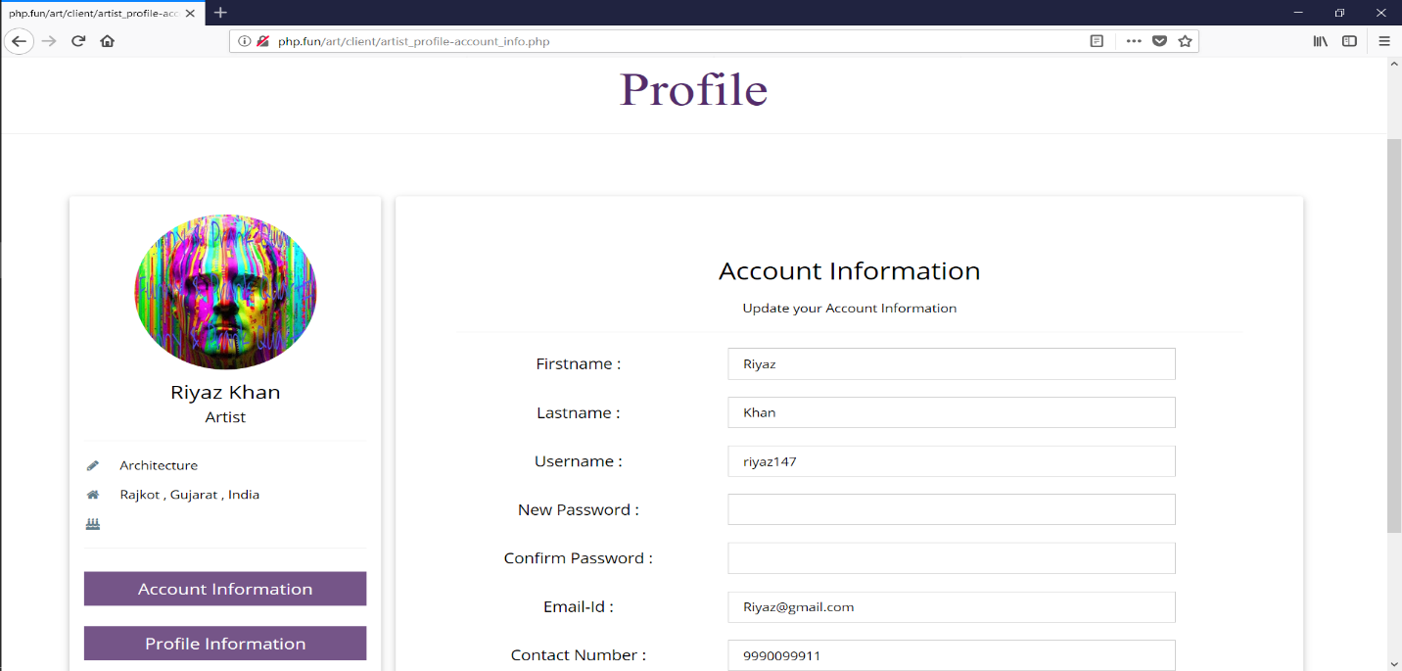

Figure : Artist Update Profile-Account-Info

The above picture shows user interface of Artist Update Profile-Account-Info.

1. Artist Update Profile-Profile-Info

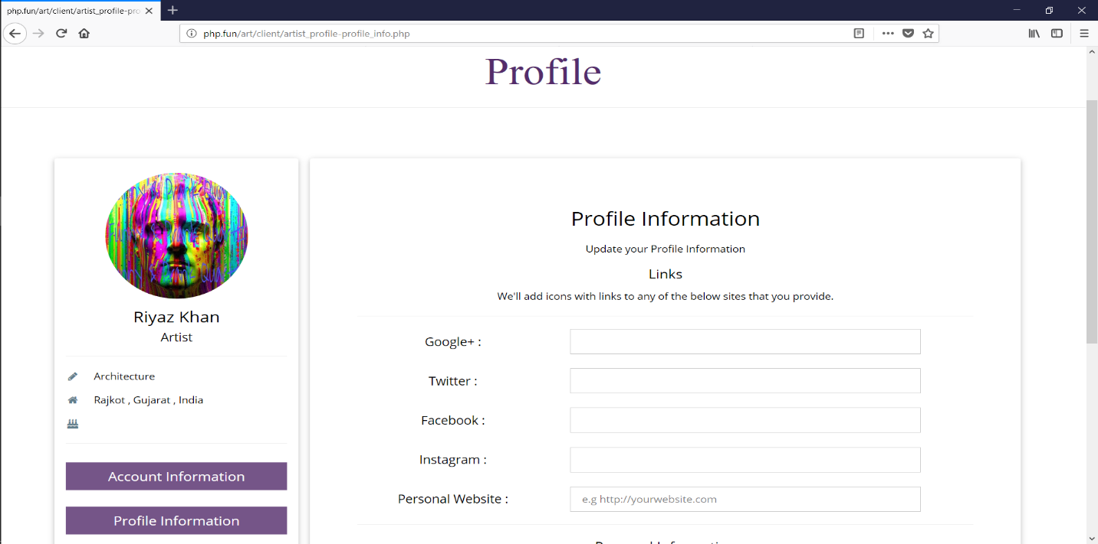

Figure : Artist Update Profile-Profile-Info

The above picture shows user interface of Artist Update Profile-Profile-Info.

1. Customer Home

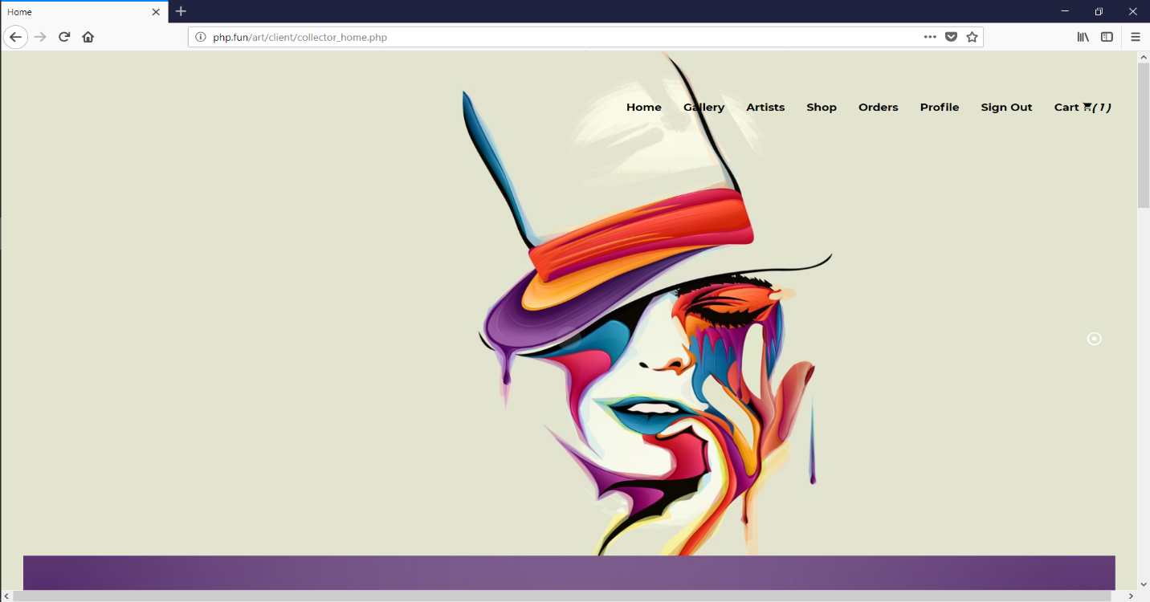

Figure : Customer Home

The above picture shows user interface of Customer Home.

1. Customer View-Artist-Profile

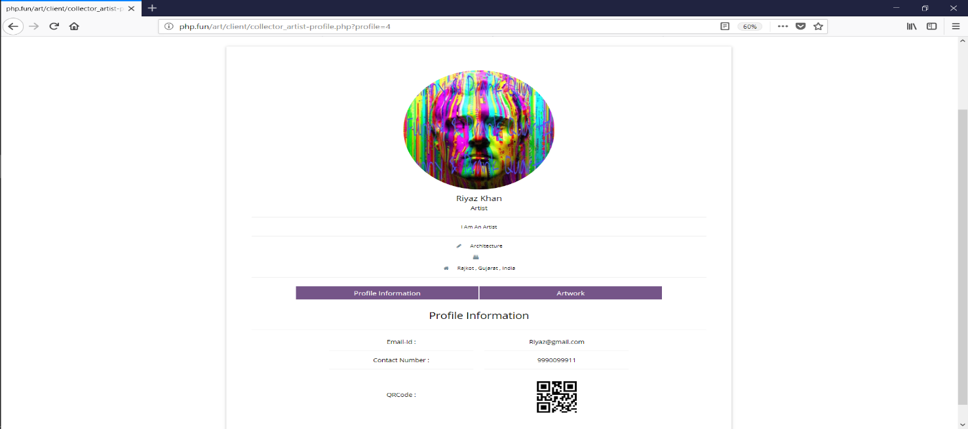

Figure : Customer View-Artist-Profile

The above picture shows user interface of Customer View-Artist-Profile screen.

1. Customer Profile

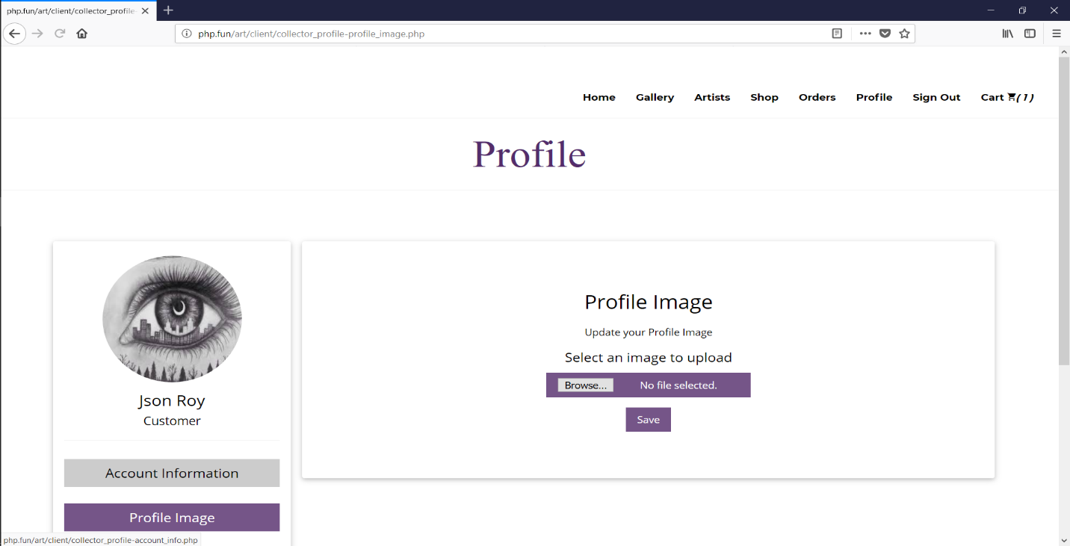

Figure : Customer Profile

The above picture shows user interface of Customer Profile screen.

1. Cart

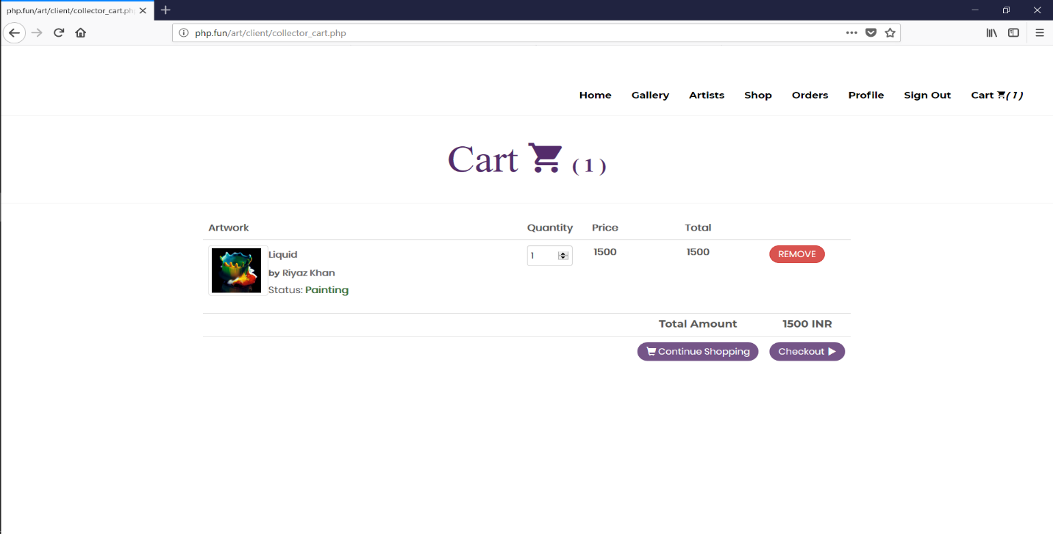

Figure : Cart Page

The above picture shows user interface of Cart screen.

1. Checkout

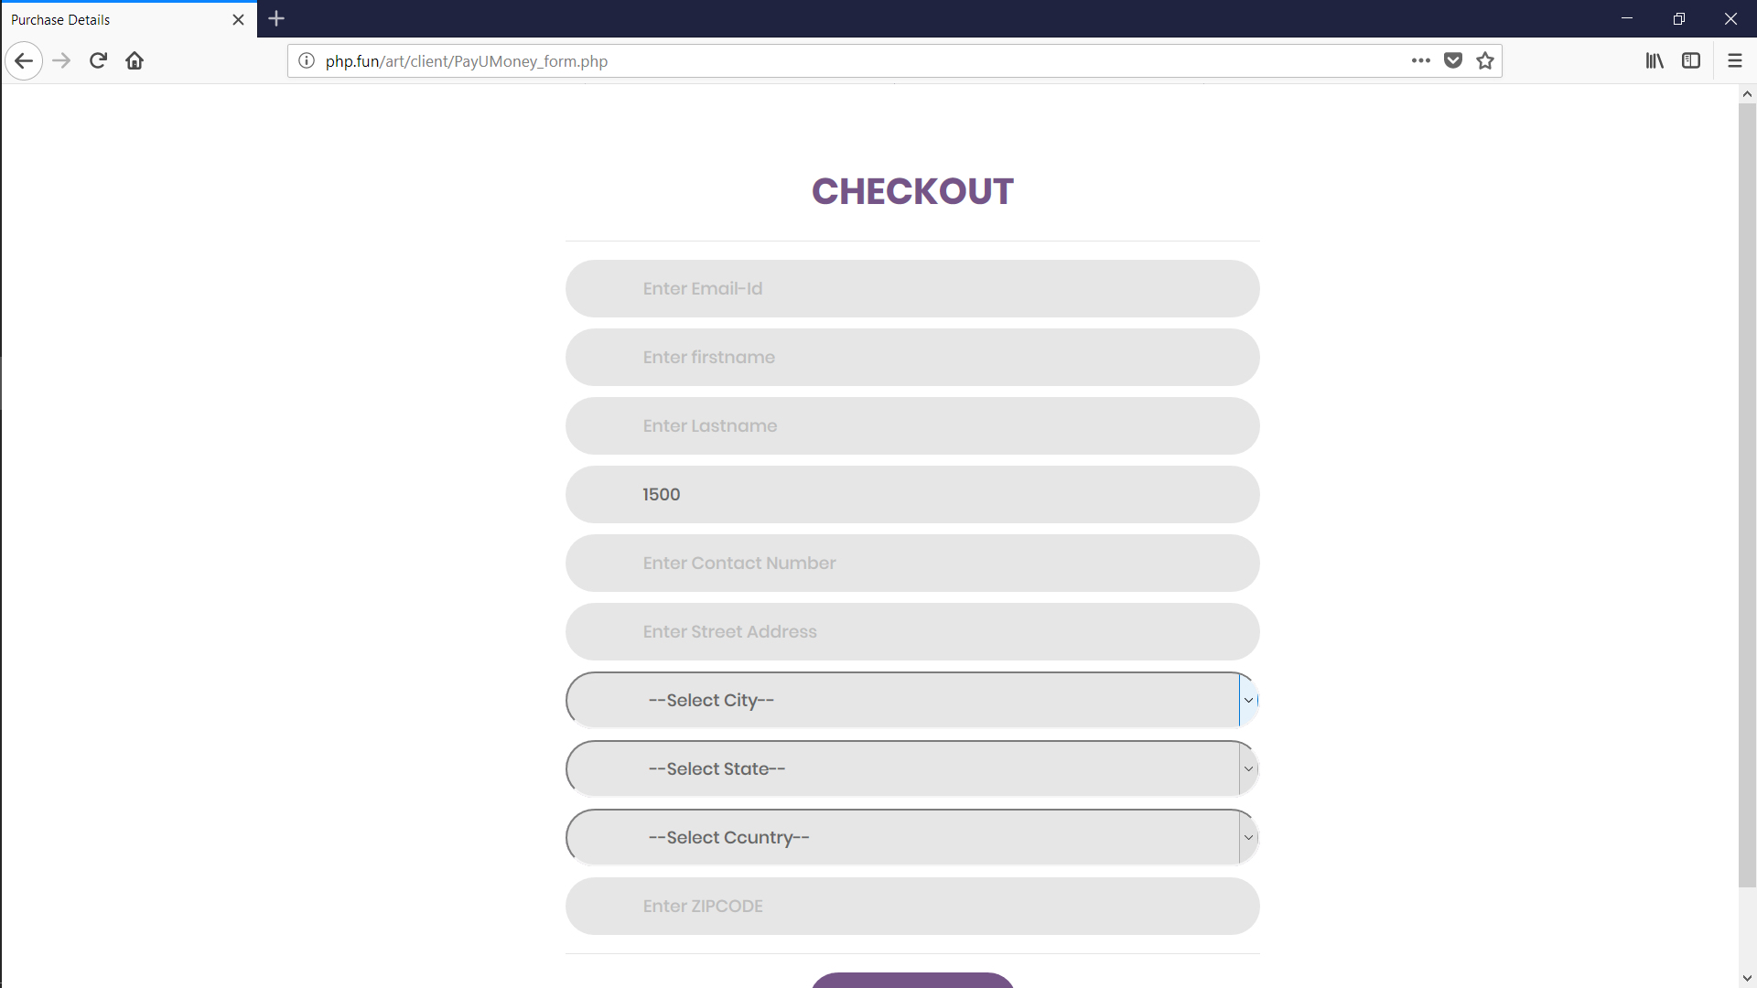

Figure : Checkout Page

The above picture shows user interface of Checkout screen.

# Testing

## Verification

1. **Test Case: Login**

Table : Test Case: Login

|  |  |  |  |  |  |  |
| --- | --- | --- | --- | --- | --- | --- |
| **Test case no:** | **Components** | **Description** | **Input values** | **Expected Output** | **Actual Output** | **Remarks** |
| 1 | Username | All input | Null | Please enter  Valid username. | Please enter  Valid username. | Fail |
|  | Username | All input | [a-z,A-Z,0-9] | Accept | Accept | Pass |
| 2 | Password | All input | Null | Please enter Password | Please enter Password | Fail |
|  | Password | All input | Not null | Accept | Accept | Pass |
| 3 | Login Button | Perform event | Click while all or some field are null | Display proper message for all fields | Display proper message for all fields | Fail |
|  | Login Button | Perform event | Not null | Accept | Accept | Pass |

1. **Test Case: Artist Registration**

Table : Test Case: Artist Registration

|  |  |  |  |  |  |  |
| --- | --- | --- | --- | --- | --- | --- |
| **Test case no** | **Components** | **Description** | **Input values** | **Expected output** | **Actual output** | **Remarks** |
| 1 | Firstname | Enter Firstname | null | This field is required | This field is required | Fail |
|  | Firstname | Enter Firstname | [a-z, A-Z] | Accept | Accept | Pass |
| 2 | Lastname | Enter Lastname | null | This field is required | This field is required | Fail |
|  | Lastname | Enter Lastname | [a-z, A-Z] | Accept | Accept | Pass |
| 3 | Username | Enter Username | Null | This field is required | This field is required | Fail |
|  | Username | Enter Username | [a-z, A-Z,0-9, @, _, .] | This field is required | This field is required | Pass |
| 4 | Password | All input | Null | This field is required | This field is required | Fail |
|  | Password | All input | invalid | Invalid input | Invalid input | Fail |
|  | Password | All input | Not null | Accept | Accept | Pass |
| 5 | Confirm password | All input | Null | This field is required | This field is required | Fail |
|  | Confirm password | All input | Mismatch with password | Invalid input | Invalid input | Fail |
|  | Confirm password | All input | Not null | Accept | Accept | Pass |
| 6 | Email | Enter email | invalid | Invalid input | Invalid input | Fail |
|  | Email | Enter email | Email type | Accept | Accept | Pass |
| 7 | Contact no | Enter numeric value | Null | This field is required | This field is required | Fail |
|  | Contact no | Enter numeric value | Invalid | Invalid input | Invalid input | Fail |
|  | Contact no | Enter numeric value | [0-9] | Accept | Accept | Pass |
| 8 | City | Enter City | null | This field is required | This field is required | Fail |
|  | City | Enter city | [a-z, A-Z] | Accept | Accept | Pass |
| 9 | State | Enter State | null | This field is required | This field is required | Fail |
|  | State | Enter State | [a-z, A-Z] | Accept | Accept | Pass |
| 10 | Country | Enter Country | null | This field is required | This field is required | Fail |
|  | Country | Enter Country | [a-z, A-Z] | Accept | Accept | Pass |
| 11 | Profile Image | Enter File | Null | This field is required | This field is required | Fail |
|  | Profile Image | Enter File | Invalid | Invalid input | Invalid input | Fail |
|  | Profile Image | Enter File | Image File | Accept | Accept | Pass |

1. Test Case: Customer Registration

Table : Test Case: Customer Registration

|  |  |  |  |  |  |  |
| --- | --- | --- | --- | --- | --- | --- |
| **Test case no** | **Components** | **Description** | **Input values** | **Expected output** | **Actual output** | **Remarks** |
| 1 | Firstname | Enter Firstname | null | This field is required | This field is required | Fail |
|  | Firstname | Enter Firstname | [a-z, A-Z] | Accept | Accept | Pass |
| 2 | Lastname | Enter Lastname | null | This field is required | This field is required | Fail |
|  | Lastname | Enter Lastname | [a-z, A-Z] | Accept | Accept | Pass |
| 3 | Username | Enter Username | Null | This field is required | This field is required | Fail |
|  | Username | Enter Username | [a-z, A-Z,0-9, @, _, .] | This field is required | This field is required | Pass |
| 4 | Password | All input | Null | This field is required | This field is required | Fail |
|  | Password | All input | invalid | Invalid input | Invalid input | Fail |
|  | Password | All input | Not null | Accept | Accept | Pass |
| 5 | Confirm password | All input | Null | This field is required | This field is required | Fail |
|  | Confirm password | All input | Mismatch with password | Invalid input | Invalid input | Fail |
|  | Confirm password | All input | Not null | Accept | Accept | Pass |
| 6 | Email | Enter email | invalid | Invalid input | Invalid input | Fail |
|  | Email | Enter email | Email type | Accept | Accept | Pass |
| 7 | Contact no | Enter numeric value | Null | This field is required | This field is required | Fail |
|  | Contact no | Enter numeric value | Invalid | Invalid input | Invalid input | Fail |
|  | Contact no | Enter numeric value | [0-9] | Accept | Accept | Pass |
| 8 | Profile Image | Enter File | Null | This field is required | This field is required | Fail |
|  | Profile Image | Enter File | Invalid | Invalid input | Invalid input | Fail |
|  | Profile Image | Enter File | Image File | Accept | Accept | Pass |

## Validation

1. **Login Validation 1**

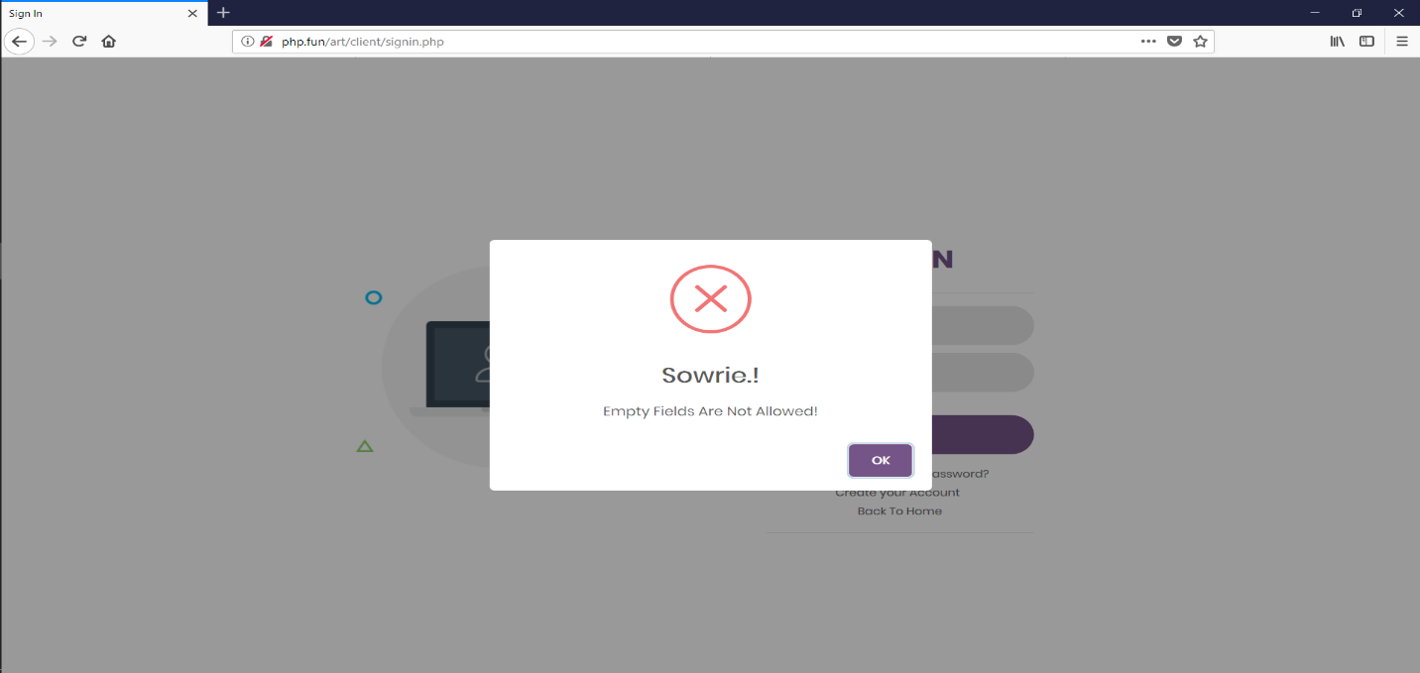

Figure : Login Validation 1

The above picture shows validation of login page.

1. **Login Validation 2**

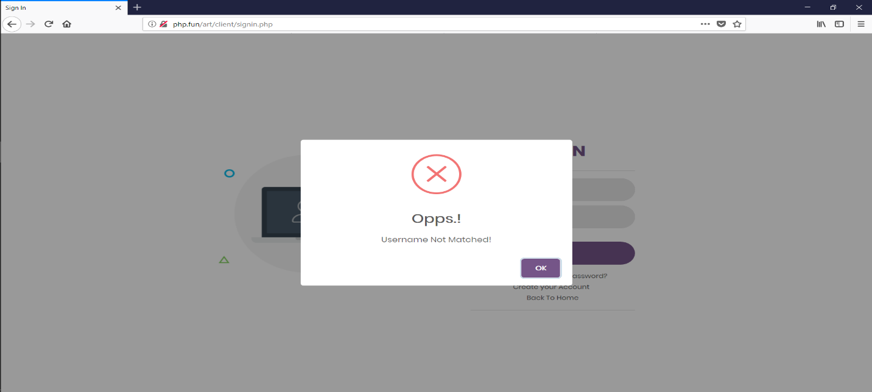

Figure : Login Validation 2

The above picture shows validation of login page.

1. Login Validation 3

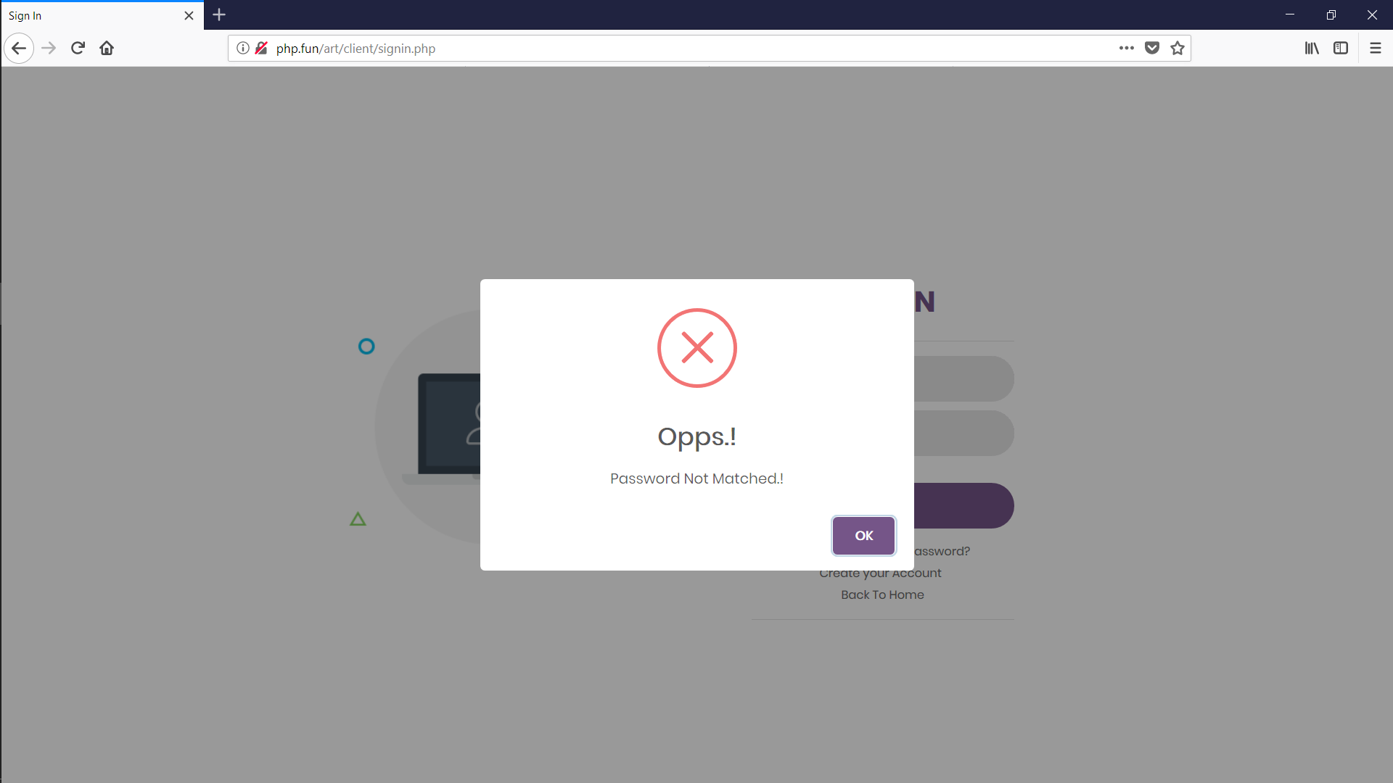

Figure : Login Validation 3

The above picture shows validation of login page.

1. Artist Registration

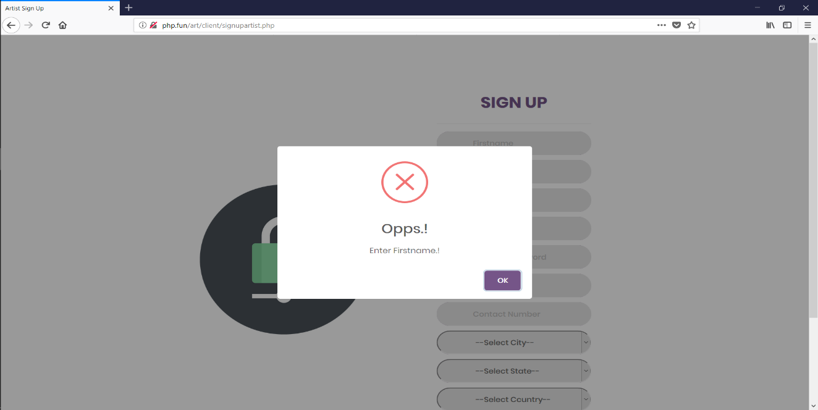

Figure : Artist Registration Validation

The above picture shows validation of artist registration page.

5. Customer Registration

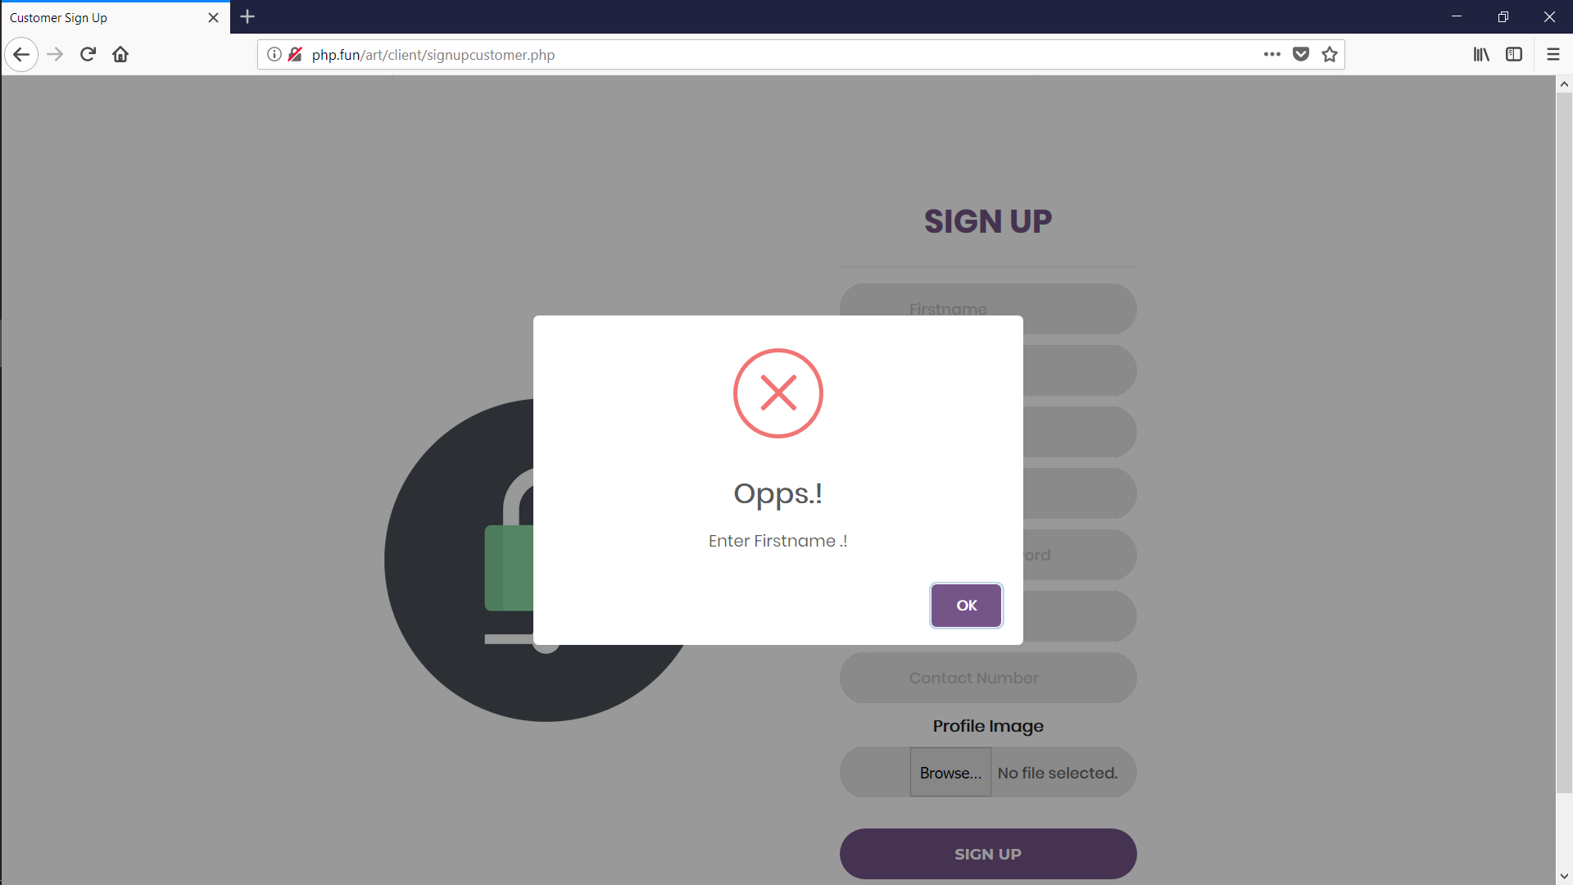

Figure : Customer Registration Validation

The above picture shows validation of artist registration page.

# Future Enhancement

**5.1** **Future enhancement and conclusion**

* + - Improvement in designing.
    - We are going to implement auction for arts.
    - Bidding functionality for customer.
    - Searching filters.
    - Blog management.

## 5.2 Learning during the Project: -

* + - The things which we have learn during project work is co-ordination and team work including time management as well as allocation of the work.
    - And also we have learned more functionality about this project.
    - And also we have learned a lot about PHP and HTML language.

# References/Bibliography

* **Web Resource**

[1] [www.youtube.com](http://www.youtube.com)

[2] [www.w3schools.com](http://www.w3schools.com)

[3] [www.Stackoverflow.com](http://www.Stackoverflow.com)

[4] [www.bootsnipp.com](http://www.bootsnipp.com)

* **Bibliography**
  1. Object Oriented Software Engineering Book by Yogesh Singh and Ruchika Malhotra